**Object Oriented Programming**

**Lab Report**

**Lab05**



|  |  |
| --- | --- |
| Group Members Name & Reg #: | **Muhammad Haris Irfan**  **(FA18-BCE-090)** |
|  |  |
| Class | Object Oriented Programming CSC241 (**BCE-4B**) |
| Instructor’s Name | Maam Amber Madeeha Zeb |

**In Lab Tasks**

**5.1 Task 1:**

**Area of a circle is π × r2 where r = radius**

**Area of a triangle is ½ × b × h where b = base, h = height**

**Write two different functions with same name that is Area to calculate the area of circle, triangle, rectangle and square**

**Solution:**The code is given below,

1 #include <iostream>

2

3 **using namespace std**;

4 **class** area

5 {

6 **private**:

7 **int** x;

8 **int** y;

9

10 **public**:

11

12 area()

13 {

14

15 }

16 **void** areaa(**float** x)

17 {

18 **cout**<<"Area of a circle with radius "<<x<<" is :" <<(3.14*x)<<**endl**;

19 }

20 **void** areaa(**float** a, **float** b)

21 {

22 **cout**<<"Area of a triangle is :" <<(0.5*a*b)<<**endl**;

23 }

24 };

25 **int** main()

26 {

27 area a;

28 a.areaa(4.5);

29 a.areaa(4.5,4.5);

30

31 **return** 0;

32 }

**Console Output is shown below.**

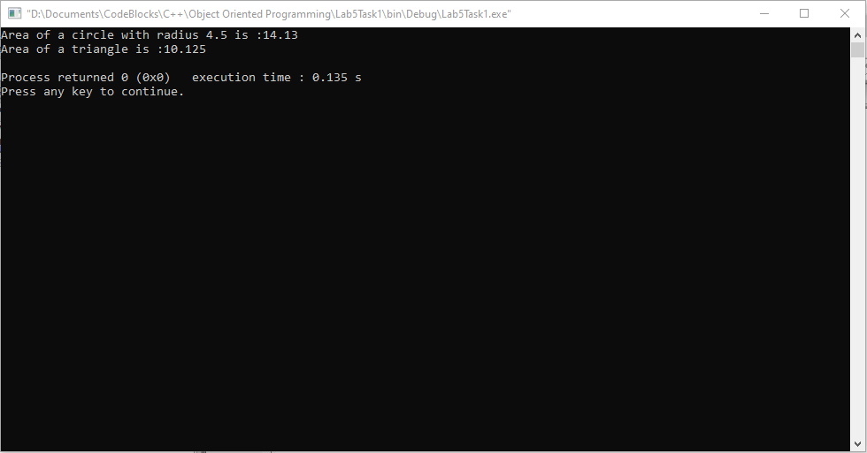

____________________________

**5.2 Task:2**

**Write a definition of a Counter class having one private data member count of integer type. This class has following functions**

* **void inc_count( ); // will increment the value of count by 1**
* **int get_count ( ); // will return the value of count**

**this class has two contructor**

* **Counter( ); // that initialize count by 0**
* **Counter (int i); // that initialize the count by i**

Create two objects of Counter class. Write a cout statement in constructor and then check whether that statement appear when two object are created. Then increment object 1 3 times and increment object 2 4 times and display their count values.

Solution:

I am attaching my code below,

1 #include <iostream>

2

3 **using namespace std**;

4

5 **class** counterClass

6 {

7 **private**:

8 **int** x;

9

10 **public**:

11

12 counterClass()

13 {

14 x=0;

15 **cout**<<"Object Created"<<**endl**;

16 }

17 counterClass(**int** i)

18 {

19 x=i;

20 }

21

22 **void** inc_count()

23 {

24 x=x+1;

25 }

26

27 **int** get_count()

28 {

29 **cout**<<"The Value of count is: "<<x<<**endl**;

30 }

31 };

32 **int** main()

33 {

34 counterClass a,b;

35 a.inc_count();

36 a.inc_count();

37 a.inc_count();

38

39 b.inc_count();

40 b.inc_count();

41 b.inc_count();

42 b.inc_count();

43

44 a.get_count();

45 b.get_count();

46

47 **return** 0;

48 }

The result for this program is shown below,

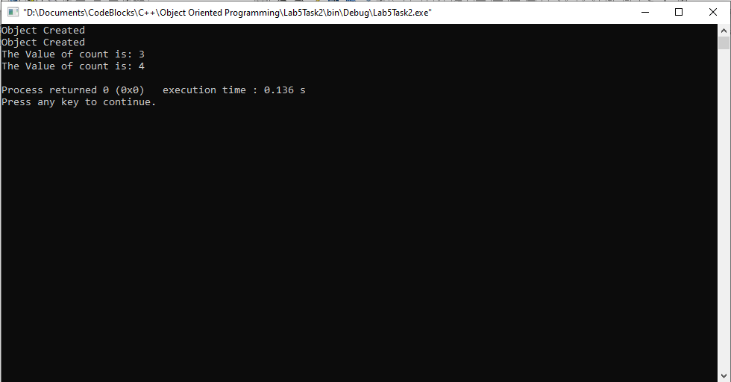

_____________________________

**5.3 Task:3**

**Write a definition of class named Race. It has following private data member**

* **carNo (int)**
* **driverID (int)**
* **carModel (int)**

**The class has one constructor Race (int, int, int) that initializes the values of carNo, driverID and carModel. Race class has following member functions**

* **void InputValues( ) // this will be used to input values of data member of Book object from user**
* **void setValues(int cn, int di, int cm); // it will assign values of cn, di and cm to carNo, driverID and carModel respectively**
* **void display( ); // it displays the value of private**

Create two object of Race class. Assign values using InputValues and setValues function and display them using display function.

Solution:

I am attaching my code below,

1 #include <iostream>

2

3 **using namespace std**;

4

5

6 **class** Race

7 {

8 **private**:

9 **int** carNO;

10 **int** driverID;

11 **int** carModel;

12

13

14

15 **public**:

16 Race()

17 {

18

19 }

20

21 Race(**int** x, **int** y, **int** z)

22 {

23 carNO=x;

24 driverID=y;

25 carModel=z;

26 }

27

28 **void** inputvalues()

29 {

30 **cout**<<"Enter Car No?"<<**endl**;

31 **cin**>>carNO;

32 **cout**<<"Enter driver id?"<<**endl**;

33 **cin**>>driverID;

34 **cout**<<"Enter Car Model?"<<**endl**;

35 **cin**>>carModel;

36

37 }

38

39 **void** setvalues(**int** a, **int** b, **int** c)

40 {

41 carNO=a;

42 driverID=b;

43 carModel=c;

44 }

45

46 **void** display()

47 {

48 **cout**<<**endl**<<"Car No: "<<carNO<<**endl**;

49 **cout**<<"Driver ID: "<<driverID<<**endl**;

50 **cout**<<"Car Model: "<<carModel<<**endl**<<**endl**;

51

52 }

53 };

54

55

56

57 **int** main()

58 {

59 Race a,b;

60 a.setvalues(4,5,6);

61 b.inputvalues();

62 a.display();

63 b.display();

64 **return** 0;

65 }

the result for this program is shown below,

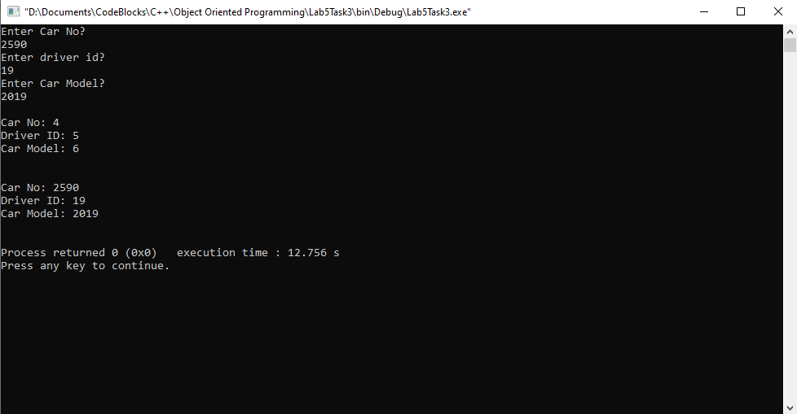

_____________________________

**5.4 Task:4**

**Write a definition of a distance class as shown in the example 4.2 above. Make all the appropriate function constant. Include a constant data member called id of integer type.**

**Create two object constant and non-constant. Assign values and display them. Also check what happens**

* **If you try to modify private data member of an object from the definition of const function**
* **If you try to modify the private data member of const object from the definition of non-constant function.**

Solution:

I am attaching my code below,

1 #include <iostream>

2 **using namespace std**;

3 **class** Distance //English Distance class

4 {

5 **private**:

6 **int** feet;

7 **float** inches;

8 **public**:

9 Distance(){

10 **cout**<<"default constructor"<<**endl**;

11 feet = 0; inches = 0;

12 }

13 Distance(**float** mtrs){

14 // this constructor convert meters to feet and inches

15 **cout**<<"one argument constructor"<<**endl**;

16 **float** ft = mtrs * 3.28084; // convertinf meters to feet

17 feet = (**int**) ft; // extracting int part from ft

18 inches = (ft - feet)*12; // converting decimal part of ft into inches

19 }

20 Distance (**int** f, **float** i){

21 **cout**<<"two argument constructor"<<**endl**;

22 feet = f; inches = i;

23 }

24 **void** setdist(**int** ft, **float** in) **const**{ //set Distance to args

25 feet = ft;

26 inches = in;

27 }

28 **void** getdist()**const** { //get length from user

29 **cout** << "\nEnter feet: "; **cin** >> feet;

30 **cout** << "Enter inches: "; **cin** >> inches;

31 }

32 **void** initialize( ) **const**{

33 feet = 0;

34 inches = 0;

35 }

36 **void** showdist( ) **const**{ //display distance

37 **cout** << "feet = "<< feet <<"\t inches = "<<inches<<**endl**;

38 }

39 };

40 main()

41 {

42 /*two objects are created so default constructor is called two times*/

43 Distance dist1, dist2; // objects data member are initialize by default constructor

44 **const** Distance dist6;

45 /* if default constructor is not present then

46 we have to call initialize function with each

47 object to initialize its private data member */

48 //dist1.initialize(); // in comments because we have

49 //dist2.initialize(); // default constructor

50 dist1.setdist(11, 6.25); //set dist1 values using setdist function

51 Distance dist3(3, 5.75); // here 2 argument constructor will be called

52 // that initialize dist3 data member with 3 and 5.75 values

53 Distance dist4(1); // here 1 argument construct will be called

54 dist6(11,76.8)

55 **cout** << "dist1 : "; dist1.showdist();

56 **cout** << "dist2 : "; dist2.showdist();

57 **cout** << "dist3 : "; dist3.showdist();

58 **cout** << "dist4 : "; dist4.showdist();

59 **cout** << "dist6 : "; dist6.showdist();

60

61 }

In both the cases the compiler will give us an error as we cannot change or update a constant variable.

_____________________________

POST LAB

6.1 Question 1:

**Write a definition of class named Date that contains three elements the month, the day of the month, and the year, all of type int.**

* **Write two constructors, a default constructor (that initialize each data element of object with zero) and a constructor that takes three parameters (the month, the day of the month, and the year) and initialize the data member of the object with these parameters.**
* **Write a function void printDate() that displays the data elements of the object.**
* **Write a function void setDate(int, int, int) that takes three parameters (he month, the day of the month, and the year) and initialize the data member of the object with these parameters.**

**Write a main function create two object of class Date, the data member of one object is initialized with zero through default constructor. The data member of second object is initialized with some values using a constructor that takes three parameters. Page 24 of 80**

Prompt the user to input date (the month, the day of the month, and the year) in a main function, assign these values to the first object (using function setDate) and then display the value of the data members of two objects using function printDate().

Solution:

I am attaching my code below,

1 #include <iostream>

2

3 **using namespace std**;

4

5 **class** Date

6 {

7 **private**:

8 **int** day;

9 **int** month;

10 **int** year;

11

12 **public**:

13

14 Date()

15 {

16 day=0;

17 month=0;

18 year=0;

19 }

20 Date(**int** x, **int** y, **int** z)

21 {

22 day=x;

23 month=y;

24 year=z;

25 }

26

27 **void** printDate()

28 {

29 **cout**<<day<<"/"<<month<<"/"<<year<<**endl**;

30

31 }

32 **void** setDate(**int** a, **int** b ,**int** c)

33 {

34 day=a;

35 month=b;

36 year=c;

37 }

38

39 };

40

41 **int** main()

42 {

43 **int** x,y,z;

44 Date one;

45 Date two(3,9,20);

46

47 **cout**<<"Enter a date in format dd/mm/yy?"<<**endl**;

48 **cin**>>x;

49 **cin**>>y;

50 **cin**>>z;

51 one.setDate(x,y,z);

52 one.printDate();

53 two.printDate();

54

55 **return** 0;

56 }

The result for this program is shown below,

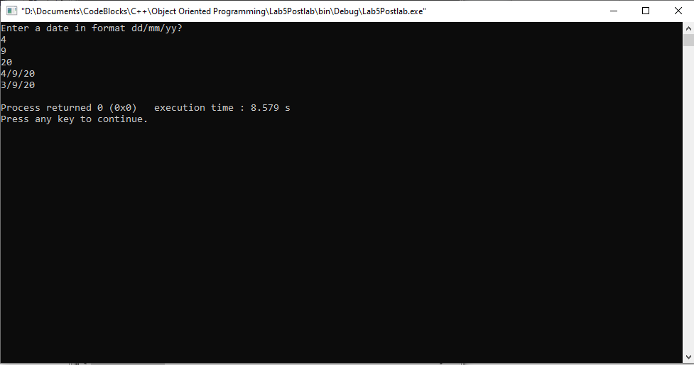

______THE END________

_______________